Issue 14 – Meeting 33 10 October 2017

|  |  |
| --- | --- |
| At this meeting, the TANK Group agreed there needs to be less nutrient and sediment entering the Ahuriri and Waitangi Estuaries. The Group is already investigating how to reduce sediment and will look at what is required to lower nutrient loads by 10 – 50%.  The Group also agreed on water quality ‘states and objectives’ for TANK’s rivers, grouping the rivers according to similar types and characteristics. Water quality has to improve in some rivers, so the group will work with scientists and industry groups to identify how to reduce nutrient inputs from land. Downstream this will be a win-win for the estuaries. | |
| **VIDEO # 1**  Take a look at the first of five videos introducing the TANK PLAN and the TANK Group.  Also, look out for future videos on:  Ahuriri Estuary Healthy Waterways Storm Water and Farmers/ Growers. |  |

**ESTUARIES – Anna Madarasz-Smith, HBRC Coastal Water Quality Scientist**

There is too much sediment, too many nutrients and storm water contaminants affecting estuary and waterway health. Algal blooms, poor clarity, low oxygen and muddiness are further proof.

Anna reviewed the current poor state of the estuaries and set out to answer the question “How do we improve the Ahuriri and Waitangi estuaries?” She recommended using estuary guideline values for nutrients and sediment, based on a state of good estuary quality, and using local and other north island data to work this out.

Anna then looked at what good freshwater quality data would be (using guideline values for water quality) and recommended a nutrient reduction amount based on good freshwater state with actual measured states. In plain English, this tells us what a more natural load to the estuary would look like under ideal conditions. To get to this, actions will be needed from town and country people - upstream landowners and adjacent municipal authorities - to meet these targets.

|  |
| --- |
| **Ahuriri Estuary - Proposed Target for Nutrient Concentrations** |
| **Waitangi Estuary – Proposed Target for Nutrient Concentrations** |

**TANK AGREED - Estuaries**TANK Group members agreed nutrient and sediment inputs into the estuary needed to reduce. They agreed it was not acceptable to allow further degradation. The Group agreed that sediment and nutrient reduction or improvement would need to be significant and agreed to further investigate what would be needed to meet a 10-50% reduction in loads to the estuaries.

**RIVER WATER QUALITY – Sandy Haidekker, HBRC Water Quality Scientist**

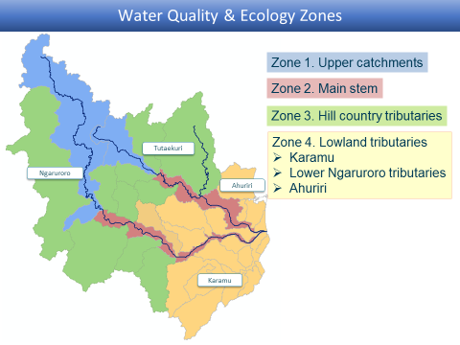The project will now use four water management zones to group catchment areas with similar river types and characteristics.

🡨 The zones are upper catchments, mid-to-low river main stems, hill country tributaries, and lowland tributaries.

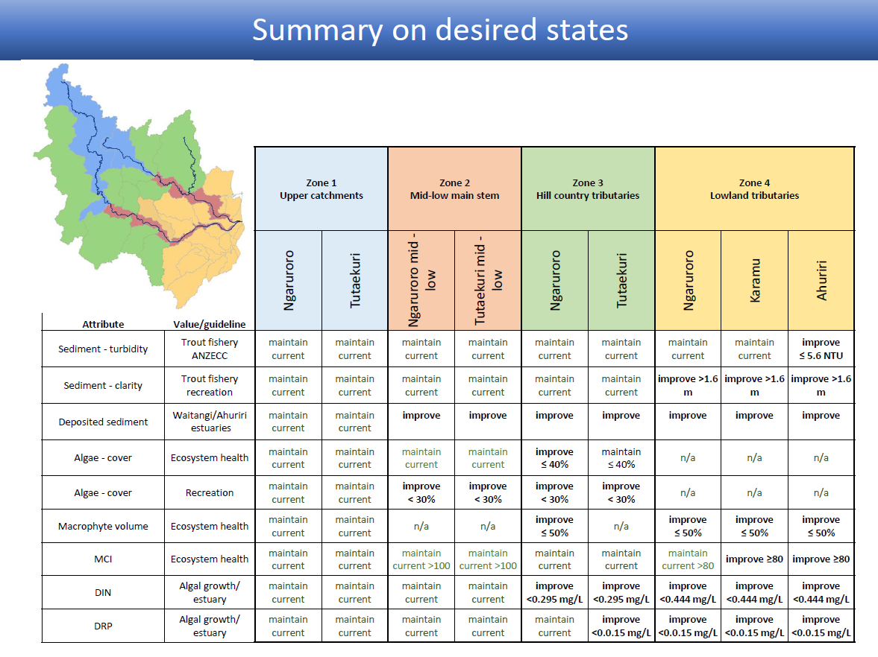

**TANK AGREED – River Water Quality**

The TANK Group agreed with Sandy’s detailed analysis of where improvement is needed in each of four water management zones. This was broken down into ammonia, nitrate, E.coli, sediment, algae, macro invertebrate index, etc. They also agreed with her recommendations for a desired water quality state – see the summary above – linked back to the values identified by the TANK Group.

**LEARNING FROM TUKUTUKI PLAN – Nathan Heath, HBRC Land Services Manager**  
Nathan provided the group with a description of how the Tukituki plan is being implemented and described some of the challenges and learnings from that process so far. He stressed the importance of conveying the overall vision, getting buy-in and involving farmers in decision-making, versus imposing rules on them.

The Tukituki approach taken by HBRC’s land management team included a ‘hot spot’ focus on priority catchments - areas that ‘need action now’, a Farm Plan focus to draw 1,100 landowners to stock exclusion, riparian planting and other good practice measures, as well as specific actions to address Nitrogen and Phosphorus management.

Nathan observed that needs for expertise and technical advice for farmers have increased greatly. Resources required for the implementation of the Tukituki Plan have been considerable, noting that the Ruataniwha Water Storage Scheme only added public confusion and contention to the understanding and implementation of the Tukituki Plan.

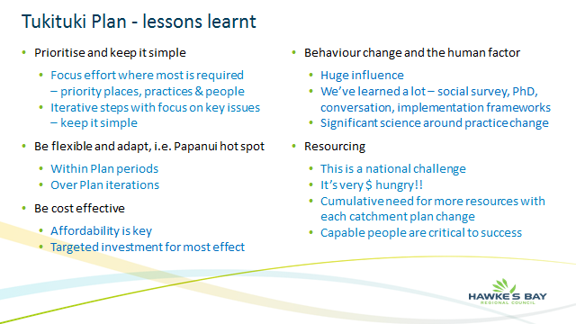**HOW TO MANAGE NUTRIENTS – Mary-Anne Baker, TANK Policy Advisor**

We need to do more modelling work to understand the effects of land use and soil contributions on nutrient loss to help us answer questions about how best to manage these. It was suggested that the Economic Assessment Working Group and industry bodies work to identify the best solutions to reduce nutrient losses to meet TANK Group objectives.

**TANK AGREED – Managing Nutrients**  
The TANK Group agreed that the Economic Assessment Working Group and industry bodies   
consider a menu of management options to reduce nutrient losses to the estuary and present these back to the TANK Group for deciding a preferred approach.

|  |  |
| --- | --- |
| **WCO – James Palmer, HBRC CEO**  The Ngaruroro/ Clive River Water Conservation Order will be considered by a Special Tribunal in two parts. The Tribunal will meet first on 14 November to consider the upper reaches of the Ngaruroro River (Whanawhana cableway and above). The panel awaits advice from HBRC by 31 January to confirm the TANK process is on track. If so the panel will consider the lower reaches of Ngaruroro and Clive Rivers in May 2018. Details about the process are on EPA’s website:  [epa.govt.nz/Resource-management/wco](http://www.epa.govt.nz/Resource-management/wco)  **NEXT MEETING**  18 October – we’ll cover the impact of different flows on fish and native birds, impact of stream depleting groundwater, security of supply at various flows, and flows for Ngaruroro and Tutaekuri social-economic assessment. | **TANK PLAN – Updated Booklet**  We’ve updated our summary booklet on the issues and progress of the TANK PLAN. Find it [online](http://www.hbrc.govt.nz/assets/Document-Library/TANK/TANK-booklet2017.pdf) or contact [Drew](mailto:drew@hbrc.govt.nz?subject=TANK%20Plan%20booklet%202017) at HBRC for a copy.    cid:dfb95d80-e59a-4cb8-a9e0-9c33618af363@ausprd01.prod.outlook.com |
| hbrc.govt.nz search: #tankresources  © 2017, HBRC  Please share this newsletter-panui  [Mary-Anne.Baker@hbrc.govt.nz](mailto:Mary-Anne.Baker@hbrc.govt.nz) |